The Rosendale Recreation Commission presents
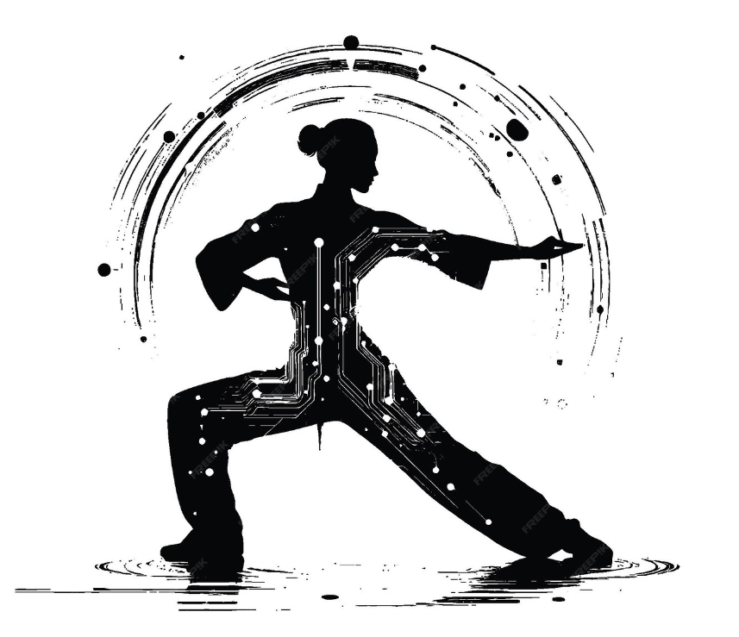
Classes in Qi Gong
The ancient Chinese movement practice

Taught by Jesse Towey

Thursdays 4:30 – 5:30
October 24, 31, November 7, 14, 21, December 5
Rosendale Community Center, 1055 Route 32, Rosendale

Classes are free and open to the Public. All ages and abilities are welcome.

For more information, call the Recreation Office 658-8198.

